Milestone One: 3D Scene Proposal
Jeremiah (Jay) Case
SNHU
CS-330
Professor Iles
7/10/2026

Milestone One: 3D Scene Proposal
Coffee Station Scene
For my project proposal, I selected a coffee station as the 2D scene that I will recreate in a three-dimensional environment using C++ and OpenGL. The scene will be based on a photograph of a coffee station or coffee bar containing several common household objects. The main objects in the scene will include a coffee maker, cream mug, coffee canister, sugar canister, glass cookie jar, and paper coffee cups. A countertop will serve as the grounding surface for the scene.
A coffee station is a good choice for this project because the objects are recognizable and can be recreated using basic three-dimensional shapes. This will allow me to demonstrate my understanding of shape construction, transformations, textures, lighting, and camera controls without making the project too difficult to complete.
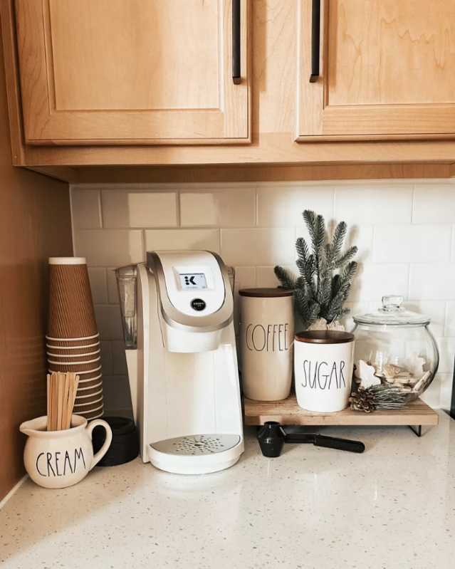
Figure 1. Reference image for the proposed coffee station scene.
Note. Image from ashleighamberstyle on LTK.
Objects to Be Replicated
The coffee maker will be the main object in the scene. It will also be the most complex object because it will be constructed from several basic shapes. The body of the coffee maker can be represented by a box, while a tapered cylinder and cylinder can be used to model the brewing chamber and cup platform. Additional small cylinders may be used to represent the buttons, lid, and other details.
The cream mug will be created using a cylinder for the body and a torus for the handle. The mug is a good object to include because its shape is simple but easily recognizable. The coffee and sugar canisters will each be represented using cylinders with additional cylinders or spheres used for the lids. The glass cookie jar will be created using a sphere for the main container and a cylinder for the lid. The wooden display shelf will be modeled using scaled boxes, while the stack of paper coffee cups will be represented using multiple cylinders.
These objects are good choices because they provide a variety of shapes, sizes, and materials. The coffee maker contains plastic and metal components, the glass cookie jar introduces a transparent material, the cream mug and canisters represent ceramic surfaces, and the wooden display shelf adds another material that can be enhanced through texture mapping.

Basic 3D Shapes
The following basic shapes will be used to create the coffee station:
Object | Basic 3D Shapes
Countertop | Plane
Coffee Maker | Box, Cylinder, Tapered Cylinder
Coffee Canister | Cylinder
Sugar Canister | Cylinder, Sphere
Cream Mug | Cylinder, Torus
Glass Cookie Jar | Cylinder, Sphere
Wooden Display Shelf | Box
Paper Coffee Cups | Cylinder

The scene will use at least six different basic shapes: a plane, box, cylinder, tapered cylinder, sphere, and torus. This exceeds the requirement to use at least four different basic three-dimensional shapes. The countertop plane will ground the other objects and provide a surface on which they can be positioned.

Overall Scope
The coffee station scene will be interesting to explore while remaining achievable within the scope of the course. Most of the objects can be constructed by scaling, rotating, and positioning basic shapes. These transformations are fundamental OpenGL techniques that allow developers to manipulate objects within a three-dimensional scene (LearnOpenGL, n.d.). The coffee maker will provide an opportunity to combine several shapes into a larger object, while the cream mug, coffee canister, sugar canister, glass cookie jar, wooden display shelf, and paper coffee cups will add variety to the scene.
Textures can be used to represent materials such as wood, ceramic, glass, plastic, and metal. Lighting can be positioned to create reflections and shadows across the objects. Camera controls will allow the viewer to move around the coffee station and observe the scene from different angles. Overall, the coffee station will allow me to demonstrate the required OpenGL techniques while creating a realistic and visually appealing project.

References
ashleighamberstyle. (n.d.). Morning coffee | coffee bar | coffee | coffee station | Rae Dunn | coffee mug | neutral kitchen | morning routine | reusable K-Cups | Keurig [Photograph]. LTK. https://www.shopltk.com/explore/ashleighamberstyle/posts/e9b4b03b-9f17-11ed-a0ea-0242ac110003
LearnOpenGL. (n.d.). LearnOpenGL. https://learnopengl.com/
Rightware. (n.d.). 6 seriously cool ways to use 3D computer graphics. https://rightware.com/blog/6-seriously-cool-ways-to-use-3d-computer-graphics/

